UMAN NATIONAL UNIVERSITY OF HORTICULTURE
UNIVERSITY OF ŁÓDŹ

Invitation letter
International scientific and practical online conference
dedicated to the 100th anniversary of the birth of Prof. V.I. Bilous
(April 24, 2025)

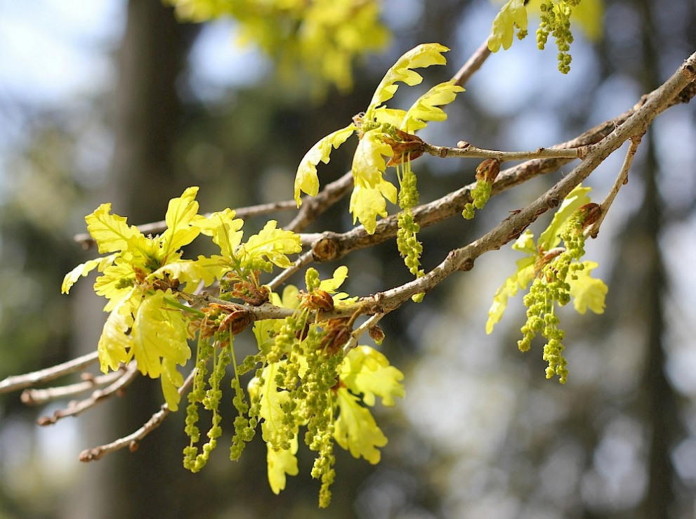

Uman – Tomaszów Mazowiecki 2025
DEAR COLLEAGUES!
The Department of Forestry of the Uman National University of Horticulture (UNUS, Uman, Ukraine) and the Branch of the University of Łódź in Tomaszów Mazowiecki (UŁ, Tomaszów Mazowiecki, Poland) invite you to participate in the International Scientific and Practical Online Conference dedicated to the 100th anniversary of the birth of V.I. Bilous, which will be held on April 24, 2025.

Organizing Committee:
Volodymyr SHLAPAK, Dr. of Agricult. Sci., Prof. – UNUS (Uman, Ukraine);
Dr. hab. Heorhiy HRYNYK, Assoc. Prof. – UŁ (Tomaszów Mazowiecki, Poland);
Svitlana ADAMENKO, Cand. of Biol. Sci. – UNUS (Uman, Ukraine).

Scientific Committee:
Dr. hab. Jacek BRZÓZKO, Assoc. Prof. – UŁ (Tomaszów Mazowiecki, Poland);
Dr. Radosław GAWRYŚ – Forest Research Institute (FRI) (Sękocin Stary, Poland);
Dr. hab. Heorhiy HRYNYK, Assoc. Prof. – UŁ (Tomaszów Mazowiecki, Poland);
Dr. Olena HRYNYK, Assoc. Prof. – FRI (Sękocin Stary, Poland);
Prof. Dr. hab. eng. Tomasz Krzysztof OSZAKO – Białystok University of Technology (Bialystok, Poland);
Dr. Piotr SELIGER, Assoc. Prof. – UŁ (Tomaszów Mazowiecki, Poland);
Dr. hab. Paweł STANISZEWSKI – Warsaw University of Life Sciences (WULS) (Warsaw, Poland);
Dr. Robert TOMUSIAK – WULS (Warsaw, Poland);
Dr. Rafał WOJTAN – WULS (Warsaw, Poland);
Natalia VYSOTSKA, Cand. of Agricult. Sci. – Estonian University of Life Sciences (Tartu, Estonia).
Dr. hab. Dorota ZAWADZKA, Assoc. Prof. – UŁ (Tomaszów Mazowiecki, Poland);
Svitlana ADAMENKO, Cand. of Biol. Sci., Assoc. Prof. – UNUS (Uman, Ukraine);
Anatoliy BALABAK, Dr. of Agricult. Sci. – UNUS (Uman, Ukraine);
Oleksandr BALABAK, Dr. of Agricult. Sci., Prof. – UNUS (Uman, Ukraine);
Oleksandr BAYURA, Cand. of Agricult. Sci. – Assoc. Prof. of the Department of Forestry, UNUS (Uman, Ukraine);
Halyna ISCHUK, Cand. of Agricult. Sci., Assoc. Prof. – UNUS (Uman, Ukraine);
Oleksandr KRATIUK, Dr. of Biol. Sci., Polissia National University (PNU) (Zhytomyr, Ukraine);
Hryhoriy KRYNYTSKYY, Dr. of Biol. Sci., President of Forestry Academy of Sciences of Ukraine – Ukrainian National Forestry University (UNFU) (Lviv, Ukraine).
Serhiy KOVAL, Cand. of Agricult. Sci., Assoc. Prof. – UNUS (Uman, Ukraine);
Iryna KOZACHENKO, Cand. of Agricult. Sci., Assoc. Prof. – UNUS (Uman, Ukraine);
Svitlana KURKA, Cand. of Biol. Sci., Assoc. Prof. – UNUS (Uman, Ukraine);
Vasyl LAVNYY, Dr. of Agricult. Sci., Prof. – UNFU (Lviv, Ukraine);
Petro LAKYDA, Dr. of Agricult. Sci., Prof. – State Forest Resources Agency of Ukraine (Kyiv, Ukraine);
Svitlana LOS, Cand. of Agricult. Sci., Senior Researcher – Ukrainian Order "Sign of Honour" Research Institute of Forestry and Forest Melioration named after G. M. Vysotsky (RIFFM) (Kharkiv, Ukraine);
Valentyna MAMCHUR, Cand. of Agricult. Sci., Assoc. Prof. – UNUS (Uman, Ukraine);
Svitlana MASLOVATA, Cand. of Agricult. Sci., Assoc. Prof. – UNUS (Uman, Ukraine);
Oleksandr OSTAPCHUK, Cand. of Agricult. Sci., Assoc. Prof. – UNUS (Uman, Ukraine);
Valentyn POLISHCHUK, Dr. of Agricult. Sci., Prof. – UNUS (Uman, Ukraine);
Volodymyr SHLAPAK, Dr. of Agricult. Sci., Prof. – UNUS (Uman, Ukraine);
Yuri SIRUK, Cand. of Agricult. Sci., Assoc. Prof. – PNU (Zhytomyr, Ukraine);
Viktor TKACH, Dr. of Agricult. Sci., Prof. – RIFFM (Kharkiv, Ukraine);
Roman VASYLYSHYN, Dr. of Agricult. Sci., Prof. – National University of Life and Environmental Sciences of Ukraine (Kyiv, Ukraine);
Volodymyr VITENKO, Dr. of Agricult. Sci., Prof. – Uman National University of Horticulture (Uman, Ukraine);

Secretary:
Iryna IVASHCHENKO, Cand. of Agricult. Sci., Assoc. Prof. – Uman National University of Horticulture (Uman, Ukraine).

Thematic areas of the conference:
1. Current problems of forestry, non-wood forest product, forest measurement, forest management and economics.
2. Artificial reforestation, afforestation, breeding, seed production, genetics, biotechnology.
3. Current state and prospects for the development of landscape gardening.
4. Complete biological research.
5. Environmental ecology and nature conservation.
6. Prospects of propagation of ornamental and fruit plants.

Venue: online on the Zoom platform.
Participation in the conference: speech (presentation) – 15 min., message (poster) (5 min.)
Conference languages: Ukrainian, Polish, English.
Presentations and posters must be prepared in English.
Participation in the conference is free.

To submit an application for participation in the conference, you must send: the title of the work, the full name of the educational or research institution, city, country, abstract (up to 350-400 words) and keywords in the language of publication (Ukrainian, Polish) and in English language.
An electronic collection of conference abstracts will be prepared as part of the conference. An electronic certificate of participation will be sent to the authors within 15 days after the event.

Terms:
1. Application deadline: March 24, 2025.
2. Decision on acceptance of work for participation in the Conference: by March 31, 2025.
3. Submission of presentation/poster by accepted participants: by April 15, 2025
(email: forestry@udau.edu.ua). Participation in the conference is free.
4. Conference: April 24, 2025.

Materials are considered received if the organizing committee has confirmed the receipt of electronic materials by letter to your email address. In the absence of confirmation, please resend the materials within a week from the date of the first sending.
The conference program and the corresponding links for remote participation (Zoom platform) will be sent to participants after April 15, 2025.

Poster (participation in the conference in the form of a report) involves presenting the research results on a poster (maximum two-three slides). The structural part of the work (title of the article, introduction, presentation of the main material, conclusions) is presented on the poster.

Contact for detailed information:

+38 (04744) 3-43-79, +38(050) 702-57-41
Oleksandr Bayura
+38 (04744) 3-43-79, +38 (067) 782-28-47
Ivashchenko Iryna
APPLICATION
for participation in the International Anniversary Scientific and Practical Online Conference dedicated to the 100th anniversary of the birth of V.I. Bilous
Uman - Tomashiv Mazovetskyi, April 24, 2025.
Surname ________________________________________________________________
Name ___________________________________________________________________
Science degree _________________________________________________________
Academic title ____________________________________________________________
Position _________________________________________________________________
Organization _____________________________________________________________
Phone _________________________________________________________________
e-mail___________________________________________________________________
Title of the report ____________________________________________________________
________________________________________________________________________
Thematic areas _________________________________________________________
Participation form _________________________________________________________

TITLE
(FONT 14 pt, SINGLE LINE SPACING, CAPITAL LETTERS)
Author(s) First & Last Name (font Times New Roman 12 pt, italic)
Full name of educational or scientific institution (organization), city
(font regular 10 pt, single line spacing, small letters, italic, width alignment)
Abstract: 350-400 words (font regular 10 pt, single line spacing, small letters, width alignment). Keywords: 5‒7 words. Keywords should represent the content of the material and should not repeat words in the title of the abstract.

